D • Bode Plot

Problem
Consider the AC circuit below. We will assume that the circuit is in steady-state. Thus, the voltage at nodes 1 and 2 are given by v₁ = V_{S} cos ω t and v₂ = V_{R} cos ( ω t + θ ) where V_{S} is the voltage of the source, ω is the frequency (in radians per second), and t is time. V_{R} is the magnitude of the voltage drop across the resistor, and θ is its phase.
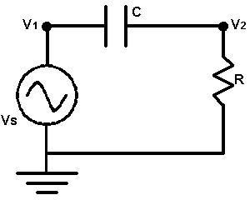
You are to write a program to determine V_{R} for different values of ω. You will need two laws of electricity to solve this problem. The first is Ohm’s Law, which states v₂ = i R where i is the current in the circuit, oriented clockwise. The second is i = C d/dt (v₁ – v₂) which relates the current to the voltage on either side of the capacitor. “d/dt” indicates the derivative with respect to t.
The input will consist of one or more lines. The first line contains three real numbers and a non-negative integer. The real numbers are V_{S}, R, and C, in that order. The integer, n, is the number of test cases. The following n lines of the input will have one real number per line. Each of these numbers is the angular frequency, ω.

Output
For each angular frequency in the input you are to output its corresponding V_{R} on a single line. Each V_{R} value output should be rounded to three digits after the decimal point.

Example
Input  1.0 1.0 1.0 9  0.01  0.031623  0.1  0.31623  1.0  3.1623  10.0  31.623  100.0 | Output  0.010  0.032  0.100  0.302  0.707  0.953  0.995  1.000  1.000

